**Assignment – 3**

**Build CNN Model for Classification of Flowers**

|  |  |
| --- | --- |
| Assignment Date | 02 October 2022 |
| Student Name | Vemula Muniseker |
| Student Roll Number | 111419205043 |
| Maximum Marks | 2 Marks |

**TASKS:**

1. Download the dataset

1. Image Augmentation

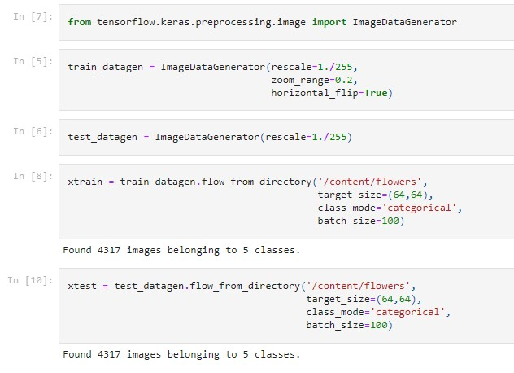

1. Create model

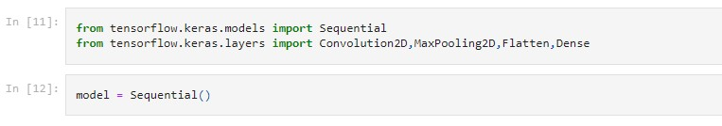

1. Adding Layers

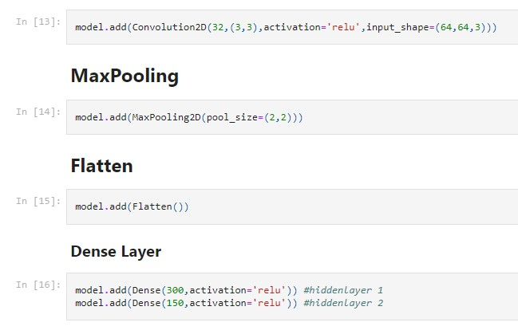

1. Compile the model



1. Fit the model

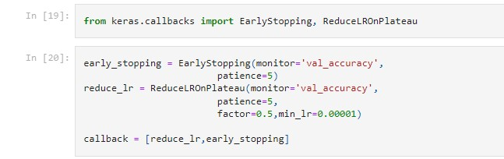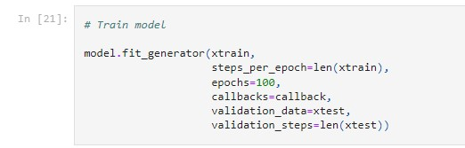

Epoch 1/100

44/44 [==============================] - 40s 894ms/step - loss: 1.4975 - accuracy: 0.4003 - val_loss: 1.2238 - val_accuracy: 0.4964 - lr: 0.0010

Epoch 2/100

44/44 [==============================] - 39s 883ms/step - loss: 1.1079 - accuracy: 0.5548 - val_loss: 1.1712 - val_accuracy: 0.5395 - lr: 0.0010

Epoch 3/100

44/44 [==============================] - 40s 907ms/step - loss: 1.0301 - accuracy: 0.5956 - val_loss: 0.9753 - val_accuracy: 0.6284 - lr: 0.0010

Epoch 4/100

44/44 [==============================] - 39s 886ms/step - loss: 0.9719 - accuracy: 0.6206 - val_loss: 0.9336 - val_accuracy: 0.6275 - lr: 0.0010

Epoch 5/100

44/44 [==============================] - 39s 878ms/step - loss: 0.8994 - accuracy: 0.6518 - val_loss: 0.8369 - val_accuracy: 0.6919 - lr: 0.0010

Epoch 6/100

44/44 [==============================] - 39s 886ms/step - loss: 0.8470 - accuracy: 0.6750 - val_loss: 0.8504 - val_accuracy: 0.6889 - lr: 0.0010

Epoch 7/100

44/44 [==============================] - 39s 884ms/step - loss: 0.8215 - accuracy: 0.6891 - val_loss: 0.7804 - val_accuracy: 0.7100 - lr: 0.0010

Epoch 8/100

44/44 [==============================] - 40s 918ms/step - loss: 0.7763 - accuracy: 0.7074 - val_loss: 0.7501 - val_accuracy: 0.7206 - lr: 0.0010

Epoch 9/100

44/44 [==============================] - 39s 887ms/step - loss: 0.7232 - accuracy: 0.7301 - val_loss: 0.7413 - val_accuracy: 0.7285 - lr: 0.0010

Epoch 10/100

44/44 [==============================] - 39s 884ms/step - loss: 0.6905 - accuracy: 0.7352 - val_loss: 0.6529 - val_accuracy: 0.7607 - lr: 0.0010

Epoch 11/100

44/44 [==============================] - 39s 885ms/step - loss: 0.6785 - accuracy: 0.7461 - val_loss: 0.7277 - val_accuracy: 0.7246 - lr: 0.0010

Epoch 12/100

44/44 [==============================] - 40s 911ms/step - loss: 0.6417 - accuracy: 0.7626 - val_loss: 0.6243 - val_accuracy: 0.7688 - lr: 0.0010

Epoch 13/100

44/44 [==============================] - 39s 890ms/step - loss: 0.6232 - accuracy: 0.7642 - val_loss: 0.5709 - val_accuracy: 0.7869 - lr: 0.0010

Epoch 14/100

44/44 [==============================] - 39s 882ms/step - loss: 0.5917 - accuracy: 0.7741 - val_loss: 0.6153 - val_accuracy: 0.7772 - lr: 0.0010

Epoch 15/100

44/44 [==============================] - 39s 884ms/step - loss: 0.5703 - accuracy: 0.7878 - val_loss: 0.5209 - val_accuracy: 0.8050 - lr: 0.0010

Epoch 16/100

44/44 [==============================] - 39s 881ms/step - loss: 0.5262 - accuracy: 0.8087 - val_loss: 0.5211 - val_accuracy: 0.8117 - lr: 0.0010

Epoch 17/100

44/44 [==============================] - 40s 907ms/step - loss: 0.5024 - accuracy: 0.8156 - val_loss: 0.3861 - val_accuracy: 0.8622 - lr: 0.0010

Epoch 18/100

44/44 [==============================] - 39s 889ms/step - loss: 0.4733 - accuracy: 0.8288 - val_loss: 0.3981 - val_accuracy: 0.8536 - lr: 0.0010

Epoch 19/100

44/44 [==============================] - 39s 887ms/step - loss: 0.4625 - accuracy: 0.8309 - val_loss: 0.3904 - val_accuracy: 0.8582 - lr: 0.0010 Epoch 20/100

44/44 [==============================] - 39s 889ms/step - loss: 0.4534 - accuracy: 0.8309 - val_loss: 0.5840 - val_accuracy: 0.7802 - lr: 0.0010

Epoch 21/100

44/44 [==============================] - 39s 887ms/step - loss: 0.4899 - accuracy: 0.8251 - val_loss: 0.4176 - val_accuracy: 0.8464 - lr: 0.0010

Epoch 22/100

44/44 [==============================] - 39s 885ms/step - loss: 0.3994 - accuracy: 0.8543 - val_loss: 0.3450 - val_accuracy: 0.8728 - lr: 0.0010

Epoch 23/100

44/44 [==============================] - 39s 896ms/step - loss: 0.4214 - accuracy: 0.8434 - val_loss: 0.3122 - val_accuracy: 0.8955 - lr: 0.0010

Epoch 24/100

44/44 [==============================] - 39s 880ms/step - loss: 0.3556 - accuracy: 0.8740 - val_loss: 0.3274 - val_accuracy: 0.8795 - lr: 0.0010

Epoch 25/100

44/44 [==============================] - 39s 882ms/step - loss: 0.3834 - accuracy: 0.8608 - val_loss: 0.2577 - val_accuracy: 0.9099 - lr: 0.0010

Epoch 26/100

44/44 [==============================] - 40s 915ms/step - loss: 0.3258 - accuracy: 0.8870 - val_loss: 0.2300 - val_accuracy: 0.9187 - lr: 0.0010

Epoch 27/100

44/44 [==============================] - 39s 886ms/step - loss: 0.3285 - accuracy: 0.8819 - val_loss: 0.2780 - val_accuracy: 0.8969 - lr: 0.0010

Epoch 28/100

44/44 [==============================] - 39s 881ms/step - loss: 0.3346 - accuracy: 0.8809 - val_loss: 0.2399 - val_accuracy: 0.9166 - lr: 0.0010

Epoch 29/100

44/44 [==============================] - 39s 884ms/step - loss: 0.2992 - accuracy: 0.8911 - val_loss: 0.2409 - val_accuracy: 0.9085 - lr: 0.0010

Epoch 30/100

44/44 [==============================] - 39s 882ms/step - loss: 0.3078 - accuracy: 0.8883 - val_loss: 0.2281 - val_accuracy: 0.9155 - lr: 0.0010

Epoch 31/100

44/44 [==============================] - 40s 910ms/step - loss: 0.2466 - accuracy: 0.9155 - val_loss: 0.2137 - val_accuracy: 0.9266 - lr: 0.0010

Epoch 32/100

44/44 [==============================] - 39s 886ms/step - loss: 0.2508 - accuracy: 0.9148 - val_loss: 0.2318 - val_accuracy: 0.9192 - lr: 0.0010

Epoch 33/100

44/44 [==============================] - 39s 898ms/step - loss: 0.2238 - accuracy: 0.9201 - val_loss: 0.1724 - val_accuracy: 0.9358 - lr: 0.0010

Epoch 34/100

44/44 [==============================] - 39s 883ms/step - loss: 0.2174 - accuracy: 0.9247 - val_loss: 0.1982 - val_accuracy: 0.9314 - lr: 0.0010

Epoch 35/100

44/44 [==============================] - 40s 911ms/step - loss: 0.1841 - accuracy: 0.9375 - val_loss: 0.1722 - val_accuracy: 0.9405 - lr: 0.0010

Epoch 36/100

44/44 [==============================] - 39s 885ms/step - loss: 0.1896 - accuracy: 0.9361 - val_loss: 0.1426 - val_accuracy: 0.9502 - lr: 0.0010

Epoch 37/100

44/44 [==============================] - 39s 888ms/step - loss: 0.1942 - accuracy: 0.9349 - val_loss: 0.1617 - val_accuracy: 0.9442 - lr: 0.0010

Epoch 38/100

44/44 [==============================] - 39s 886ms/step - loss: 0.2163 - accuracy: 0.9229 - val_loss: 0.1500 - val_accuracy: 0.9470 - lr: 0.0010

Epoch 39/100

44/44 [==============================] - 39s 883ms/step - loss: 0.1751 - accuracy: 0.9363 - val_loss: 0.1106 - val_accuracy: 0.9622 - lr: 0.0010 Epoch 40/100

44/44 [==============================] - 40s 912ms/step - loss: 0.1849 - accuracy: 0.9338 - val_loss: 0.2038 - val_accuracy: 0.9266 - lr: 0.0010

Epoch 41/100

44/44 [==============================] - 39s 883ms/step - loss: 0.1617 - accuracy: 0.9486 - val_loss: 0.1293 - val_accuracy: 0.9560 - lr: 0.0010

Epoch 42/100

44/44 [==============================] - 39s 886ms/step - loss: 0.1336 - accuracy: 0.9583 - val_loss: 0.1023 - val_accuracy: 0.9641 - lr: 0.0010

Epoch 43/100

44/44 [==============================] - 39s 890ms/step - loss: 0.1275 - accuracy: 0.9590 - val_loss: 0.0941 - val_accuracy: 0.9720 - lr: 0.0010

Epoch 44/100

44/44 [==============================] - 40s 912ms/step - loss: 0.1351 - accuracy: 0.9581 - val_loss: 0.1591 - val_accuracy: 0.9456 - lr: 0.0010

Epoch 45/100

44/44 [==============================] - 39s 891ms/step - loss: 0.1275 - accuracy: 0.9574 - val_loss: 0.1165 - val_accuracy: 0.9625 - lr: 0.0010

Epoch 46/100

44/44 [==============================] - 39s 885ms/step - loss: 0.1260 - accuracy: 0.9574 - val_loss: 0.0675 - val_accuracy: 0.9773 - lr: 0.0010

Epoch 47/100

44/44 [==============================] - 39s 882ms/step - loss: 0.1650 - accuracy: 0.9423 - val_loss: 0.1186 - val_accuracy: 0.9618 - lr: 0.0010

Epoch 48/100

44/44 [==============================] - 39s 885ms/step - loss: 0.1151 - accuracy: 0.9627 - val_loss: 0.0573 - val_accuracy: 0.9822 - lr: 0.0010

Epoch 49/100

44/44 [==============================] - 40s 912ms/step - loss: 0.0819 - accuracy: 0.9743 - val_loss: 0.0733 - val_accuracy: 0.9764 - lr: 0.0010

Epoch 50/100

44/44 [==============================] - 39s 878ms/step - loss: 0.1102 - accuracy: 0.9627 - val_loss: 0.1269 - val_accuracy: 0.9578 - lr: 0.0010

Epoch 51/100

44/44 [==============================] - 39s 882ms/step - loss: 0.1004 - accuracy: 0.9666 - val_loss: 0.0730 - val_accuracy: 0.9778 - lr: 0.0010

Epoch 52/100

44/44 [==============================] - 39s 883ms/step - loss: 0.0952 - accuracy: 0.9701 - val_loss: 0.0715 - val_accuracy: 0.9787 - lr: 0.0010

Epoch 53/100

44/44 [==============================] - 40s 912ms/step - loss: 0.0953 - accuracy: 0.9683 - val_loss: 0.0742 - val_accuracy: 0.9761 - lr: 0.0010

Out[21]:

<keras.callbacks.History at 0x7f438af89490>

1. Save the model



1. Test the model

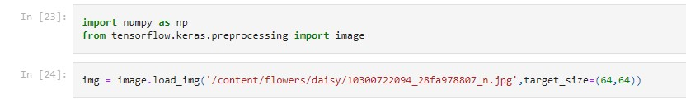

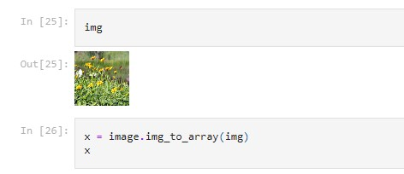

array([[[ 35., 12., 56.], [ 52., 32., 60.],

[ 59., 46., 63.], ...,

[151., 156., 124.],

[109., 133., 73.],

[162., 166., 141.]],

[[ 65., 54., 68.],

[ 92., 88., 77.],

[ 89., 85., 74.],

...,

[158., 165., 132.],

[104., 126., 77.],

[140., 153., 125.]],

[[123., 128., 88.],

[135., 143., 106.],

[132., 136., 99.],

...,

[148., 158., 121.],

[140., 163., 111.],

[138., 152., 117.]],

...,

[[ 3., 1., 14.],

[101., 122., 83.],

[ 78., 103., 63.],

...,

[ 79., 122., 6.],

[ 83., 113., 17.],

[ 98., 135., 39.]],

[[147., 172., 140.],

[145., 173., 135.],

[152., 175., 133.], ...,

[ 61., 99., 38.],

[133., 166., 113.],

[ 0., 10., 7.]],

[[149., 171., 135.],

[137., 156., 124.],

[147., 170., 126.], ...,

[ 97., 123., 60.],

[145., 182., 105.],

[105., 128., 58.]]], dtype=float32)



array([[[[ 35., 12., 56.], [ 52., 32., 60.],

[ 59., 46., 63.], ...,

[151., 156., 124.],

[109., 133., 73.],

[162., 166., 141.]],

[[ 65., 54., 68.],

[ 92., 88., 77.],

[ 89., 85., 74.], ...,

[158., 165., 132.],

[104., 126., 77.],

[140., 153., 125.]],

[[123., 128., 88.],

[135., 143., 106.],

[132., 136., 99.], ...,

[148., 158., 121.],

[140., 163., 111.],

[138., 152., 117.]],

...,

[[ 3., 1., 14.],

[101., 122., 83.],

[ 78., 103., 63.], ...,

[ 79., 122., 6.],

[ 83., 113., 17.],

[ 98., 135., 39.]],

[[147., 172., 140.],

[145., 173., 135.],

[152., 175., 133.], ...,

[ 61., 99., 38.],

[133., 166., 113.],

[ 0., 10., 7.]],

[[149., 171., 135.],

[137., 156., 124.],

[147., 170., 126.], ...,

[ 97., 123., 60.],

[145., 182., 105.],

[105., 128., 58.]]]], dtype=float32)

